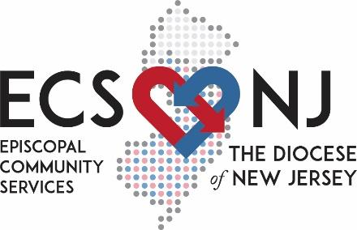
Episcopal Community Services of the Diocese of New Jersey
Grant Final Report
Fall 2021 Cycle

Basic project information
Name of Church, Town:
Project Name:
Amount of Grant:
Contact information of person completing this form (name, email, phone number):

Project update
- Date your project actually began:
- Looking back at your stated objectives from the grant application,
- what have you achieved to date? Please describe in detail.

- what parts of the plan, if any, were impossible to carry out? Please describe the circumstances that prevented your group from following the exact plan.

- Who have been the beneficiaries of this grant? Share demographics and numbers.

- Who has been a part of the implementation team for this grant and in what role? Please include their relationship to your congregation.

5. Please describe how this project will be continued or sustained.

- What surprises and unexpected learnings did you have during the course of this project? Do you have any advice for ECS-NJ?

- How did this project impact your congregation? How did it change the way you, your team, and/or your congregation think about acting as a follower of Jesus?

8. Please share a success story. Attach photos and/or videos (please orient your cellphone horizontally for videos). You could share how the grant has expanded your program or how the grant has enabled the creation of a new program. We are also looking for stories about people who have been positively impacted by the work you are doing since receiving the ECS-NJ grant or ways members of your church have grown in their faith as a result of this work. If you need more information about what we mean by success stories, please see the end of this document.

Budget update
1. Please provide your current project budget with all revenue and expenditures to-date in Excel. Please be sure to keep copies of all of your receipts, contracts, and invoices on file in case we need to ask you for them.

2. Please describe how the grant funds allowed you to carry out your project. What did you accomplish that would not have been possible without your ECS-NJ grant?

About Success Stories

Looking for and telling success stories affords the opportunity to regularly step back and celebrate achievements both big and small. A success story is a short narrative that highlights the accomplishments of a program or partnership. Success stories discuss the progress and improvement of your program and are often told through the lens of one person’s experience with your program.
Providing the stories of grant recipients and how a grant helped them make a specific difference in their community gives stakeholders, including donors, something they can relate to in an emotional and tangible way. In addition, by sharing your success story, others can discover the true value and impact of your program.
Stories of a deepened or transformed faith may inspire other churches to undertake this work and help us all consider where we see Jesus in our lives.
Some things to consider as you’re drafting your story:
- Title – should capture the overall message of the story and grab the attention of your audience
- Point of view: The story could be from the perspective of those who benefited from the program: a participant, congregation member, family member, friend, etc.
- Quote from a participant: Do you have any specific quotes from participants or partners that would support this story? Be sure to get their consent.
- Program impact: Since the program was implemented, how is life different for program recipients? (Changes in culture/norms, organizations, and behavior; increased access, etc.) What is the estimated number of people who have benefited from the program? Were there any (unintended) results that surprised you?
- Congregational impact: Since the program was implemented, how is life different for your congregation? Here you could have multiple people from your congregation sharing their perspectives. How has this deepened their faith?
The ECS-NJ Communications team may be in touch to learn more about your work or story.

